**ONIGBODE NATHAN**

SIWES  BINGHAM UNIVERSITY, NIGERIA

INTERNSHIP TECHNICAL REPORT



**BINGHAM UNIVERSITY, NIGERIA**

**STUDENT INDUSTRIAL WORK EXPERIENCE SCHEME (SIWES) HELD AT NIGERIAN TELEVISION AUTHORITY HEADQUARTERS, OPPOSITE FCTA, AREA 11, ABUJA.**

**SUBMITTED TO: DEPARTMENT OF COMPUTER SCIENCE, FACULTY OF COMPUTING, BINGHAM UNIVERSITY, KARU, NASSARAWA STATE, NIGERIA**

**SIWES TECHNICAL REPORT**

**SUBMITTED**

**BY**

**FULL NAME: ONIGBODE NATHAN**

**REGISTRATION NUMBER: BHU/21/04/05/0027**

**IN PARTIAL FULFILLMENT OF THE REQUIREMENTS FOR THE AWARD OF BACHELOR DEGREE IN COMPUTER SCIENCE**

**SEPTEMBER, 2024**

**DECLARATION**

I, **ONIGBODE NATHAN**, with Registration number **BHU/21/04/05/0027** hereby declare that the content of this technical report has been carried out by me, and it is based on the experiences that I learned during the course of the SIWES program. I declare that every external work used in this project has been fully acknowledged.

…………………. …………………….

**ONIGBODE NATHAN Date**

**BHU/21/04/05/0027**

**CERTIFICATION**

This is to certify that this technical report written by **ONIGBODE NATHAN** with Registration Number **BHU/21/04/05/0027** following a six-month SIWES training and meets the requirements governing the award of the degree of Bachelor of Science in Computer Science and is approved for its contribution to knowledge.

**ONIGBODE NATHAN (STUDENT) Date**

**MRS. OLUWATOYIN ADELAKUN ADEYEMO**

**(SUPERVISOR)** **Date**

_____________________ ______________________

**Mr. GABRIEL ANYANWU Date**

**UNIVERSITY SIWES Coordinator**

**DR. ADAMU S. USMAN** **Date**

**Head of Department**

**DEDICATION**

This technical report is dedicated to my loving parents, whose unwavering support, encouragement, and belief in my abilities have been a constant source of motivation throughout my academic journey.

All thanks belong to God Almighty the most merciful, the beneficent. I wish to express my profound gratitude to Almighty God for his assistance throughout my academic line.

My special appreciation goes to the school managements, my lecturers, and all the SIWES supervisors for their efforts.

I also dedicate this project to my sisters Naomi and Faith, and to my friends and relatives.

**ACKNOWLEDGMENT**

I would like to express my sincere gratitude to God Almighty for the gift of life. I wish to express my sincere appreciation my IT supervisor Mrs. OLUWATOYIN ADELAKUN ADEYEMO, for the guidance, inspiration and continuous support during the Six Months period of my IT. I would like to thank the HOD of Department of Computer Science Dr. Adamu S. Usman. My profound gratitude goes to the Departmental SIWES Coordinator Dr. Yakubu Aliyu Ibrahim and all the lecturers in the Department which include Dr. (Ms.) Anna B. Hassan, Dr. Faki A. Silas, Dr. Onu Egena. Dr. Oluwasegun Ishaya Adelaye, Dr. Victor Kulumph, Mrs. Oluwatoyin Adelakun Adeyemo, Mr. Musa Yusuf, Mr. Maikori Ezekiel Jenome, Mr. Barka T. Fori, Mr. Ibrahim Lawal and Mrs. Ipole Nancy. I also thank the Technologists in the Department Mr. Joseph Oladele Aremu, Mr. Ngale Langthong and Mr. Sharack Akoh. I also appreciate the Departmental Secretary Mrs. Talatu Bowman. A big thank you to all the teaching and non-teaching staff of the Faculty of Science and Technology Bingham University. I say a big thank you to my place of IT Nigerian Television Authority (NTA) for allowing me gain practical experience of theoretical aspect for my study and contributions my own quota. I would like to thank my loving parents Mr. and Mrs. ONIGBODE, for giving their support financially, morally, emotionally and spiritually. Also say thank you to my beloved sibling Naomi and Faith for being there for me always. I thank my fellow Students from the Department of Computer Science for their support and logical contributions in the various parts of my SIWES. Finally, I appreciate everyone whose name were not mention but has in one way or the other contributed to the success of this technical report. May Almighty God bless them all.

TABLE OF CONTENTS

**DECLARATION** ii

**CERTIFICATION** iii

**DEDICATION** iv

**ACKNOWLEDGMENT** v

**CHAPTER ONE** 1

**INTRODUCTION** 1

**1.1 Background of SIWES** 1

**1.2 History of the SIWES program** 1

**1.3 Location of the organization** 1

**1.4 Mission of the Organisation** 1

**1.5 Vision of the organisation** 2

**1.6 Mandate of the organisation** 2

**1.7 Contribution to Knowledge** 2

**1.8 Structure of the organization** 3

**CHAPTER TWO** 4

**NIGERIAN TELEVISION AUTHORITY (NTA)** 4

**2.1 Overview of Nigerian Television Authority** 4

**2.2 INTRODUCTION/LEGAL STATUS** 5

**2.3 VISION** 6

**2.4 MISSION** 6

**2.5 CORE VALUES OF THE NTA** 6

**2.6 CORPORATE STRUCTURE** 6

**2.7 NATIONAL SPREAD AND EXPANSION** 6

**2.8 PARTNERSHIP** 7

**2.9 CORE MANDATE** 7

**2.10 STRUCTURE OF THE ORGANIZATION** 7

**CHAPTER THREE** 8

**SIWES ACTIVITIES** 8

**3.1 TECHNICAL EXPERIENCES GAINED** 8

**3.1.1 Virtual Private Network Configuration** 8

**3.1.2 Configuration of New Systems** 10

**3.1.3 Backup and Formatting of Computers** 10

**3.1.4** **Tutorial on various applications** 11

**3.1.5** **Connection of Printers** 12

**3.2** **SOFTWARE DEVELOPMENT EXPERIENCES GAINED** 13

**3.2.1** **Python** 13

**3.2.2 MySQL** 17

**3.3 Relevance to Real-Life Situation** 18

**CHAPTER FOUR** 19

**SUMMARY, CONCLUSION AND RECOMMENDATION** 19

**4.1** **SUMMARY** 19

**4.2** **CONCLUSION** 20

**4.3** **RECOMMENDATION** 20

**REFERENCES** 21

.

**Table of Figures**

Figure 1.1 Organogram of ITF 3

Figure 2.1 NTA Logo 4

Figure 2.2 Structure of NTA 7

Figure 3.1 Virtual Private Network Configuration after connecting the system to the domain of the commission 9

Figure 3.2 Edit view of Adobe Premiere Pro 12

Figure 3.3 Entry level python: Numpy showing the product of an array’s content squared 14

Figure 3.4 Intermediate Level: Data visualizations with seaborn using FacetGrid 15

Figure 3.5 Expert Level: Transforming a data set and training the model 16

Figure 3.6 Screenshot illustrating the fitting and transformation of a data set to a model 17

Figure 3.7 Group function using MySQL 17

Figure 3.8 MySQL code with python integration which selects 3 rows from a database and prints it 18

**CHAPTER ONE**

**INTRODUCTION**

**1.1 Background of SIWES**

The Students Industrial Work Experience Scheme (SIWES) was established in Nigeria by the Nigerian Universities Commission (NUC) in 1973, mandated to bridge the gap between theoretical knowledge and practical application in tertiary education. It was introduced to address the disconnect between classroom learning and industry requirements, aiming to enhance students' employability and prepare them for professional roles in various sectors (Nigerian Universities Commission, 2020).

**1.2 History of the SIWES program**

The Industrial Training Fund, created by Decree 43, was founded in 1973, the same year that the Federal Government of Nigeria launched the Students Industrial Work Experience Scheme (SIWES) (FGN). It is a requirement for the issuance of Certificates, Diplomas, and Degrees at higher education institutions such as colleges of education, polytechnics, and universities, amongst others.

**1.3 Location of the organization**

The ITF office is located at 5th Floor, ITF House, No.6 Adetokunbo Ademola Crescent, Maitama, FCT, Abuja

**1.4 Mission of the Organisation**

The need for SIWES arose due to several factors:

1. Skill Development Gap: Graduates often lacked the practical skills required by industries, leading to challenges in securing employment.
2. Industry Relevance: There was a growing demand for graduates who could apply theoretical knowledge to real-world situations and contribute effectively to organizational goals.
3. Workplace Readiness: Employers sought candidates with hands-on experience and a thorough understanding of industry-specific practices and standards.

**1.5 Vision of the organisation**

SIWES addresses these needs through:

1. Practical Exposure: Providing students with hands-on experience in professional environments related to their fields of study.
2. Skill Enhancement: Developing technical skills, problem-solving abilities, and teamwork through supervised industrial training.
3. Industry Integration: Bridging the gap between academia and industry, ensuring graduates are well-prepared and adaptable to workplace demands (Akanbi, 2018).

**1.6 Mandate of the organisation**

SIWES holds significant relevance for students of Computer Science by:

1. Skill Acquisition: Offering opportunities to acquire practical, technical, social and other real world skill essential for my field of study.
2. -Professional Ethics Development: Fostering critical thinking, decision-making, and communication skills crucial for career readiness and advancement.
3. Industry Exposure: Providing insights into operational processes, regulatory compliance, and technological advancements within industrial settings (Oluwatobi & Oludayo, 2019).

**1.7 Contribution to Knowledge**

Participation in SIWES contributes to academic knowledge and practical insights through:

1. Hands-on Learning: Applying theoretical concepts to real-world scenarios, enhancing understanding and retention of academic material.
2. Research Opportunities: Engaging in industry-specific research, innovation, and problem-solving that contribute to advancements in industrial practices and technologies.
3. Knowledge Transfer: Facilitating collaboration between academia and industry, promoting the exchange of ideas and best practices that benefit both sectors (Adeleke & Ojo, 2020).

**1.8 Structure of the organization**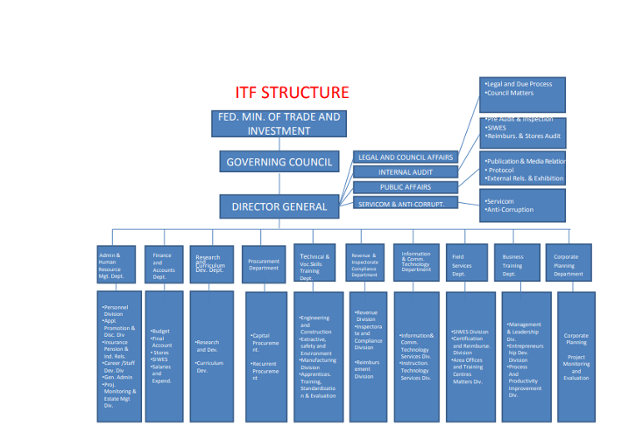

Figure 1.1 Organogram of ITF

**CHAPTER TWO**

**NIGERIAN TELEVISION AUTHORITY (NTA)**

Figure 2.1 NTA Logo

**2.1 Overview of Nigerian Television Authority**

The Nigerian Television Authority came into being in May 1977 through Decree 24 of 1977 which had retroactive effect from April, 1976.  By the Decree, all existing 12 regional television Stations established in the country between October 1959 and 1974 came under the Umbrella of the NTA which became the only body empowered to take TV Broadcasting in Nigeria. In 1976, Television and indeed Plateau State TV metamorphosed from black and white to color. Funding of the Stations became a responsibility of the Federal Government and networking of News commenced via Domestic Satellite from April 1976. NTA has maintained a systematic growth through the years from 12 Stations at inception in 1977. NTA as of today, boasts of about 100 stations, with presence in every State Capital and all Senatorial districts.

**2.2 INTRODUCTION/LEGAL STATUS**

The NTA is a parastatal in the Federal Ministry of Information. It was established by the Nigerian Television Act Cap 24 of 1976. It is the National Television Broadcasting Network for Nigeria, expressly mandated to provide as a public service in the interest of Nigeria, independent and impartial service (non-profit) activity of the NTA has sustained corresponding modifications.

In the first instance, its exclusive right for television broadcasting in Nigeria was revoked.

Secondly, the mandate to operate as a non-profit public service entity was partially revoked. It is now a Public Service partly funded by Government, television broadcasting for general reception within Nigeria. But following amendments and modifications of the enabling Act by Government, the public

partially commercialized but operates strictly within the enabling public service guidelines, the Broadcasting code and civil service structure.

Thirdly, the broadcasting mandate of the NTA has been expanded from only broadcasting to Nigeria to broadcasting to Nigeria and the world at large.

**2.3 VISION**

**To be a world class television network.**

The new vision of the NTA will reposition and strengthen the Authority through the 21st Century Television Broadcasting, dictating a new pace and direction, new expectation and reach.

**2.4 MISSION**

**To provide excellent television service world-wide and project the true African perspective.**

The new mission statement in the same vein, captures and summarizes the real essence of the former mission literature, to present in one wholesome sentence, the new direction.

**2.5 CORE VALUES OF THE NTA**

Professionalism, accuracy, credibility, impartiality, balance and objectivity, social responsibility, sensitivity, national interest, commitment to world peace and development.

**2.6 CORPORATE STRUCTURE**

The Director General is the Chief Executive Officer.

He is assisted by a team of Executive Directors who are heads of the News, Programs, Engineering, Finance and Admin, Marketing, Training and Capacity Building and Special Duties Directorates.

The Director General and the Executive Directors constitute the Board of Management charged with the day to day running of the Authority. They are also members of the Board of Directors which is composed of a part-time Chairman and seven members. The organogram of this structure is shown if figure 2.2.

**2.7 NATIONAL SPREAD AND EXPANSION**

As at the last count, NTA has 101 Stations spread across Nigeria making it the largest Television Network in Africa. Currently, there are 10 operational network centers. These centers generate and uplink network programs for the network service. They are NTA Lagos, Ibadan, Kaduna, Enugu, Sokoto, Benin, Port Harcourt, Makurdi, Jos and Maiduguri. Each Network Centre is headed by a zonal Director who oversees all stations within his/her zone.

**2.8 PARTNERSHIP**

In 2010, NTA entered a partnership with Star Times International in the area of Terrestrial Digital Transmission to fast track the graduation to Digital Broadcasting ahead of the 2015 global deadline given by the International Telecommunications union for all Television transmission in the world to digitize. The partnership is also for the purpose of increasing the revenue base of the Authority. subscription-pay TV that uses a decoder for access to its signal.

**2.9 CORE MANDATE**

The core mandates of the NTA are News and Programs. These mandates are discharged by the operations of the Directorates of News, Programs and Engineering and the newly established Multi-channels.

**2.10 STRUCTURE OF THE ORGANIZATION**

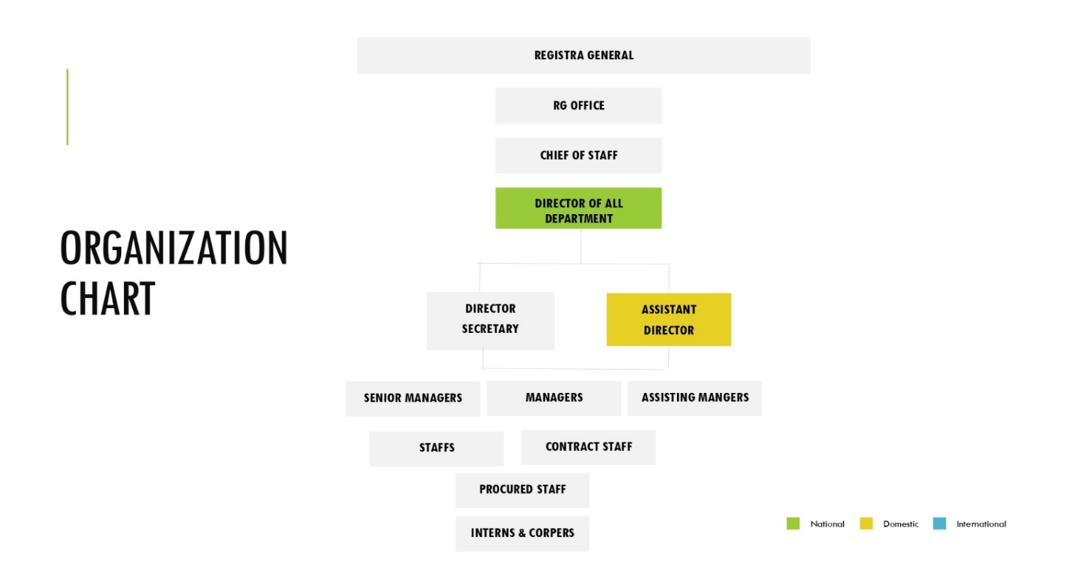

**DIRECTOR**

**DIRECTOR**

Figure 2.2 Structure of NTA

**CHAPTER THREE**

**SIWES ACTIVITIES**

**3.1 TECHNICAL EXPERIENCES GAINED**

**3.1.1 Virtual Private Network Configuration**

**During my stay in the commission, I was able to engage myself with the guidelines of the commission regarding their network security. I was able to learn about the virtual private network the commission uses and I was trained on how to setup, utilize, debug, and renew the certificate of the VPN.**

**Steps in configuring a Virtual Private Network:**

1. Identify the user.
2. Get the renewed certificate.
3. Locate the file location of the current certificate in the user’s system.
4. Replace the expired certificate with the renewed one.

But it is crucial to note that when setting up a new computer system with the VPN, the system must be connected to the domain network before the VPN configuration process begins. The explanation of the above steps is shown in fig 3.1

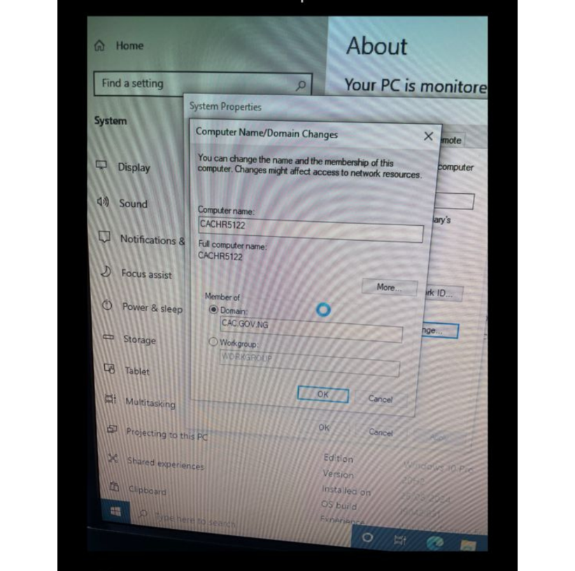

Figure 3.1 Virtual Private Network Configuration after connecting the system to the domain of the commission

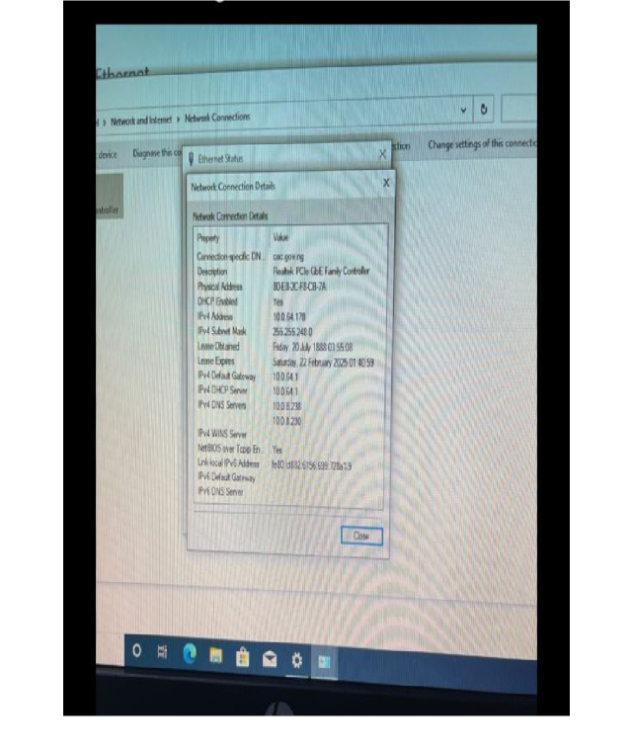

Figure 3.2 Virtual Private Network Configuration after connecting the system to the domain of the commission part 2

**3.1.2 Configuration of New Systems**

**While I was serving my internship, there were some days we set aside for the configuration of new systems entering into the commission. Given that I had not known how to configure systems before, I was trained in a workshop hosted by one of my supervisors on every step I need to take in order to set up the system successfully.**

**Steps in configuring a new system on the organizations’ standard:**

1. Ensure that the system is connected to the local area network of the organization.
2. Start up the system.
3. Set the name, then click next.
4. In the network screen set the computer to connect via domain name.
5. Input the domain name.
6. Then proceed to set up the computer as regular meaning you follow the on-screen instructions.
7. Wait for the computer to compile the configurations.
8. After that allow the system to boot
9. When the system completely boots, go to the file manager and right click.
10. Select properties from the drop down.
11. In the properties, go to advanced system properties and select the local user password setting.
12. Set the password to the default and change it to never expiring.
13. Then go to the run command (Win + R) and put in the code \\10.8.1.231 to go to the system backup of the necessary file.
14. Install all the programs there. (they include the provider VPN certificate, Microsoft Office, Google Chrome, and other essential programs for the organization)
15. After this the system is good to go. If the user has an existing account, we recover the backup of his or her account to the system.

**3.1.3 Backup and Formatting of Computers**

There were certain occasions when a staff will come for a problem which will require us to format his or her system. During these occasions, I learnt, by observation, the procedures needed to successfully format and reset a system. One of said procedures is the backing up of the system so that after the formatting, important documents will not be lost.

Steps in Backing up a Computer:

1. Create a folder in an external drive and call it the name of the user
2. Inside that drive, section the files and arrange them structurally according to the type of document.
3. Put that external drive in the new system and move the documents from the external drive to the system.

Steps in formatting a system: After the system has been successfully backed up, we have to format that system using the following steps:

1. Go to the file manager and select the main system drive.
2. Right click on it and select Format.
3. Follow the on screen directions to conclude the formatting process.
   * 1. **Tutorial on various applications**

During my internship I was trained on the editing software application “Adobe Premier” and I was shown how to use this application to edit videos for the corporation. I was able to download the application and experiment on it with various features and I believe I have experienced the app to a great deal.

We were also trained on how to use the Microsoft data visualization software “Power BI”, which is used to turn unrelated sources of data into coherent, visually interactive insights. We use this application for data analysis of various information processed throughout the corporation.

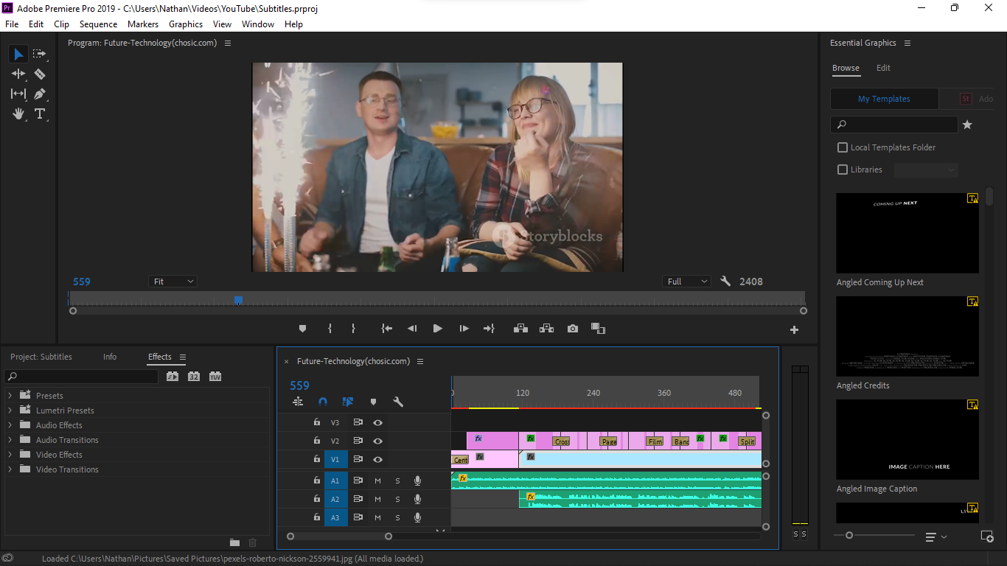

Figure 3.2 Edit view of the Adobe Premier Pro

* + 1. **Connection of Printers**

In the organization, due to the amount of documents that need to be processed, there was a huge demand for printers and as such, set ups and failures of such printers had to be handled by the ICT unit of the commission. During my internship, I was made to understand, by experience, that there are multiple ways to which one can connect a computer to a printer. Some of said ways are:

1. Through a Network: If the printer was a network printer, it will have a set up in such a way that allows It to be connected to a local area network and share the documents through said network for printing.

2. Through a Printing Cable: If the printer has no provision for network printing, we would have to manually connect the system to the printer via a printing cable to enable the staff to print his or her documents.

3. Through a Host Computer: Given that the printer was not compatible for network sharing but still needed to be used by multiple people, we were enlightened on a method which involved them connecting the printer to a computer then setting that directly connected system as a host system. Then as long as that system is on a network, any other computer that is on that network will have to share their documents to that system for them to be able to print their documents.

* 1. **SOFTWARE DEVELOPMENT EXPERIENCES GAINED**
     1. **Python**

During my Internship at the commission, I was put on a training boot camp for an intensive python course where I learnt all the basics of python at the entry level, data analysis at the intermediate level and machine learning at the expert level.

**At the entry level, I was trained on basic operations with python and how to use some of the python libraries like *Matplotlib, numpy, pandas* etc. While at the intermediate level, I was exposed to the whole theory of data analysis including its applications and relevant libraries for visualizing data, for example *seaborn, pyplot, and cufflinks.***

During this time, we were also given some projects to work on which we used to increase our understanding of the language. The excersies were very challenging but at the end of the day, we were given the solutions to them which proved to be a very effective method for our development.

I was taught about univariants, kernel density estimation, how to combine two different distribution plots with *jointplot*. I was also shown the hexagon diagram and how it is a *scatter plot* but it uses color intensity to show the density. And how a *pairplot* does all the possible combinations of all the distribution plots.

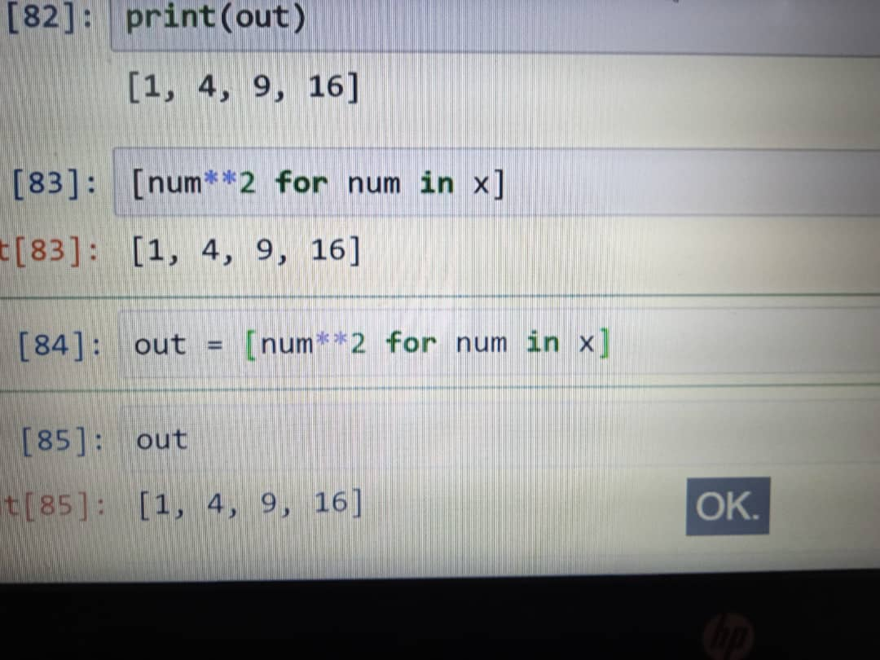

Figure 3.3 Entry level python: Numpy showing the product of an array’s content squared

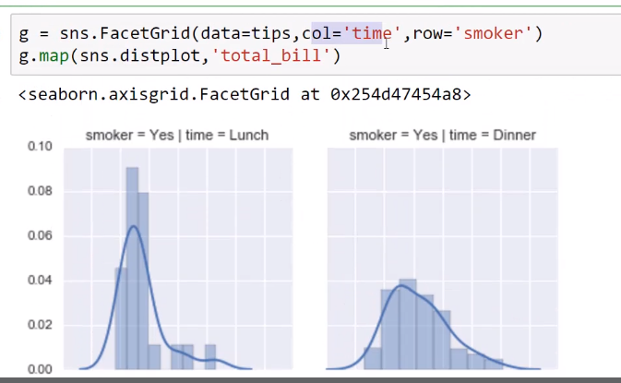

Figure 3.4 Intermediate Level: Data visualizations with seaborn using FacetGrid

Finally, at the advanced section of the course, I was trained on the concept on machine learning methodology of artificial intelligience and on. The things we covered in this section involved artificial neural network, Natural language procesing and Amazon Web Service (AWS). We were made to understand the implecations of data analysis towards the model creation and testing of the model. We also were taught about the various macine learning library and which of the packages was appropriate for the various models depending on the data we receive.

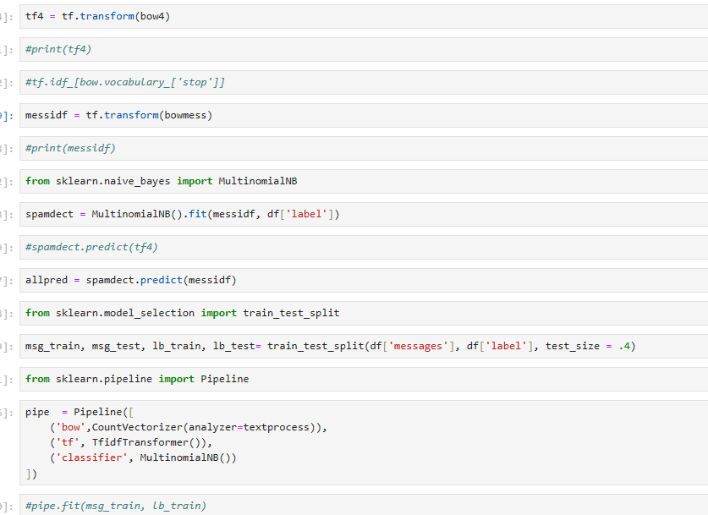

Figure 3.5 Expert Level: Transforming a data set and training the model

We were thought about the machine library *sklearn* and the format for training a model which involves

1. Getting a data set,
2. Classifying and cleaning the said data,
3. Designating a portion of the data as a testing data set,
4. Fitting and transforming the data set,
5. Training that set of data to the system.

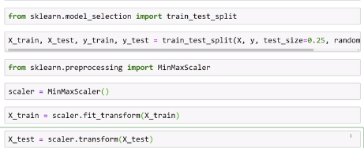

Figure 3.6 Screenshot illustrating the fitting and transformation of a data set to a model

**3.2.2 MySQL**

**MySQL is a widely-used open-source relational database management system (RDBMS) developed by Oracle Corporation. It utilizes Structured Query Language (SQL) for managing and manipulating databases. After the boot camp on machine learning with python, I was privileged to learn about the basics of MySQL and integrate it with the python I learnt, using the SPYDER IDE I was able to create some terminal applications. Most of the training we did regarding MySQL was done by assignments**

**and exercises which involved us practicing each of its commands and their applications. And finally I was able to apply them and construct a stable database with the MySQL query language.**

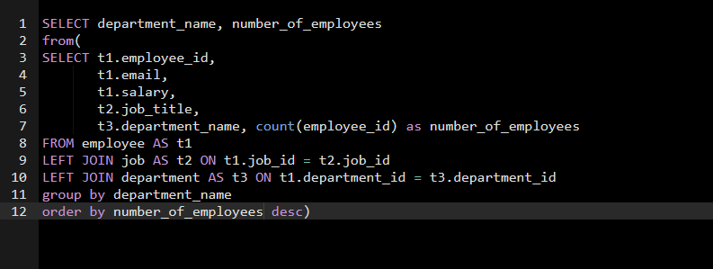

Figure 3.7 Group function using MySQL

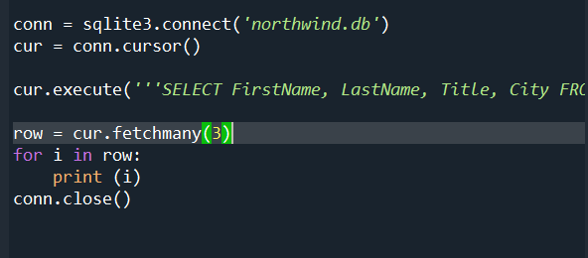

Figure 3.8 MySQL code with python integration which selects 3 rows from a database and prints it

**3.3 Relevance to Real-Life Situation**

The experience gained in the ICT at Nigerian Television Authority is directly applicable to real-world Computing scenarios. By actively participating in technical support, I acquired essential skills in analytical computing, Computer operations, and technical management. These competencies are critical for ensuring Computer ethics, meeting regulatory requirements, and supporting sustainable computer management practices in organizations served by Computer and electronics. The practical experiences gained from these analyses Nigerian Television Authority are directly applicable to real-world scenarios in Computer science and Technical analysis.

**CHAPTER FOUR**

**SUMMARY, CONCLUSION AND RECOMMENDATION**

* 1. **SUMMARY**

The Students Industrial Work Experience Scheme (SIWES) was introduced by the Nigerian Universities Commission (NUC) in 1973 to bridge the gap between theoretical knowledge and practical skills in education. During my internship at the Nigerian Television Authority (NTA), I gained hands-on experience in various technical and software development areas, including:

1. **Technical Skills:**
   1. **VPN Configuration:** Learned to set up, debug, and renew certificates for secure network communication.
   2. **System Configuration:** Trained to configure new systems, ensuring they are integrated with the organization's network.
   3. **Backup and Formatting:** Acquired skills in data backup and system formatting to avoid data loss during repairs.
   4. **Printer Connections:** Gained expertise in connecting printers via network sharing, direct connection, and host systems.
   5. **Software Usage:** Mastered tools like Adobe Premiere for video editing and Power BI for data visualization.
2. **Software Development:**
   1. **Python:** Trained in Python basics, data analysis, and machine learning, including model training with libraries like *NumPy*, *Seaborn*, and *Scikit*-learn.
   2. **MySQL:** Gained proficiency in database management using MySQL and integrated Python to develop terminal applications.

The internship provided practical insights into real-world applications of computer science, technical support, and software development, equipping me with skills vital for the industry.

* 1. **CONCLUSION**

My SIWES training at Nigerian Television Authority (NTA) has been instrumental in enhancing my knowledge and skills in Computer Science. Working in the Information and Communication Technology department provided practical insights into Computer ethics, work environments, in relation to my future endeavors.

Participating in SIWES at Nigerian Television Authority (NTA) has prepared me for a successful career in Computer science. The hands-on experience gained in Information and Communication Technology department has been instrumental in bridging the gap between theory and real-world problem-solving. It has allowed me to become a student of experience, exposing me to the intricacies regarding technical professionalism and expertise in business and financial management amongst others.

* 1. **RECOMMENDATION**

Based on my SIWES experience, I recommend that future practitioners of Computer Science in the SIWES programs focus on acquiring practical skills in quality control, network debugging, and all round technological know-how. Active engagement in industrial settings enhances professional development and prepares students to meet industry standards and challenges effectively.

**REFERENCES**

Akanbi, C. T. (2018). *Students' industrial work experience scheme: An overview. Journal of Education and Practice*, 9(2), 111-117. Retrieved on 29th September 2024.

Adeleke, J. O., & Ojo, O. S. (2020). *Bridging the gap between theory and practice: The role of SIWES in Nigeria. Journal of Vocational Education and Training*, 72(1), 98-115. Retrieved 29th September 2024.

**Federal Government of Nigeria (FGN).** (1973). Industrial Training Fund Decree 43. Retrieved 29th September 2024.

[History of NTA - *Nigerian Television Authority - Africa's Largest TV Network*](https://nta.ng/2013/04/14/history-of-nta/#:~:text=It%20was%20established%20by%20the%20Nigerian%20Television%20Act,impartial%20television%20broadcasting%20for%20general%20reception%20within%20Nigeria.). https://nta.ng/2013/04/14/history-of-nta/#:~:text=It%20was%20established%20by%20the%20Nigerian%20Television%20Act,impartial%20television%20broadcasting%20for%20general%20reception%20within%20Nigeria. Retrieved 23rd October 2024.

**International Telecommunications Union.** (2015). Guidelines for the Transition to Digital Broadcasting. Retrieved 23rd October 2024.

**Nigerian Universities Commission.** (2020). *SIWES operational guidelines for Nigerian universities. Nigerian Universities Commission.* Retrieved 10th October 2024.

Oluwatobi, S. A., & Oludayo, O. A. (2019*). Impact of SIWES on students' industrial skills and job placement in Nigeria. African Journal of Educational Management*, 3(1), 45-58. Retrieved 10th October 2024.